Course Name: Continuous Performance Management
Course Topic | Utilizing the CPM tool to bring visibility, track performance, and get feedback. | Objective | Learners will successfully help an employee use the CPM tool to stay on track with his goals, request feedback from stakeholders and have structured one-on-one meetings with his manager.

Storyboard Reviewing Guidlines
- This is a storyboard for the continuous performance simulation for managers eLearning Course
- This storyboard is not meant to represent the final look and feel of the course. It is simply to outline the module content.
- As you review this storyboard, focus solely on content accuracy and structure.
- Please do not make any edits directly to the content. Instead, add comments with your specific edits. This will allow me to track what has and has not been changed.

Screen Title: Title Screen
Text/Script | Navigation | On-Screen Graphics
{Banner Title/Heading}  Continuous Performance Management  {Subheading}  Ali is a sales manager at Al-Futtaim. Can you help him learn about continuous performance management and approach his performance as an ongoing development process?  {Button Caption}  Start | The learner will click on start. | 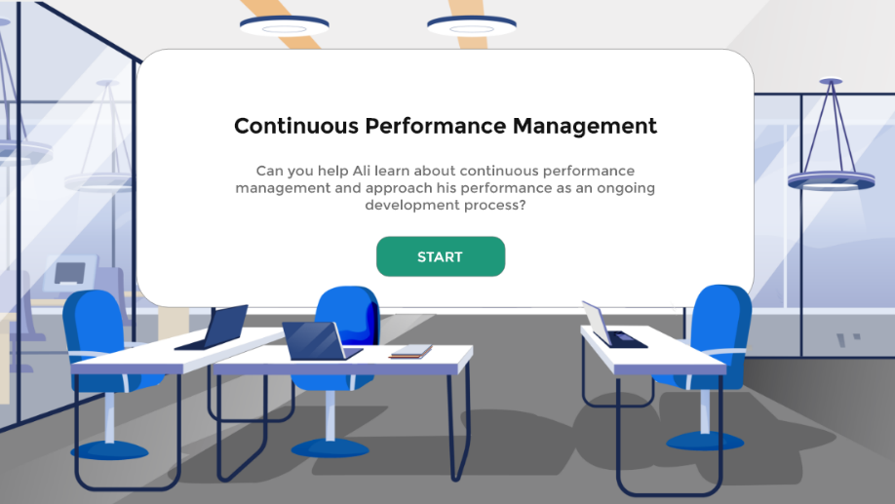
Screen Title: Role Selection
Text/Script | Navigation | On-Screen Graphics
{Banner Title/Heading}  Select your role  {Subheading}  Click on your role below to personalize your experience.  {Button Caption}  Button 1: People Manager  Button 2: Employee | The learner will click on the button according to his/her role. Depending on the button they click, they will have a personalized experience. | 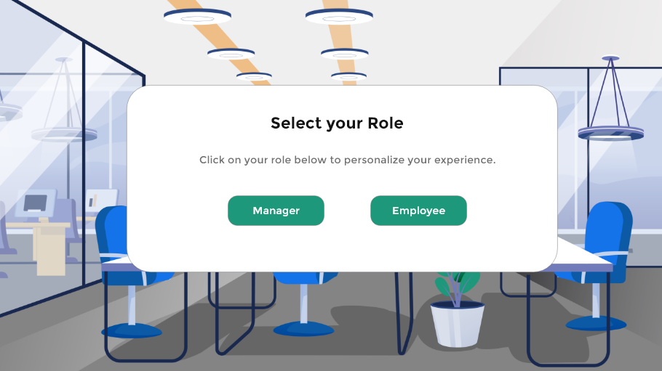
Screen Title: Introduction
Text/Script | Navigation | On-Screen Graphics
Rosmin and Ali are managers and good colleagues at Al-Futtaim. While Rosmin has been with the company for over 5 years, Ali has recently joined the team. Although they have been in their roles for different lengths of time, the two have a strong relationship and are committed to managing their teams efficiently.  However, Ali is facing challenges in managing his workload and ensuring continuous visibility of his team's progress, while also providing necessary support.  In contrast, Rosmin employs a structured approach towards her tasks and team management. She regularly seeks feedback, maintains visibility over her team's priorities, and conducts one-on-one meetings to keep her team motivated and on track. As a result, Rosmin was able to conduct structured meetings with her manager and team during end-of-year evaluations. Recognizing her proficiency, Ali turned to Rosmin for assistance in overcoming his own frustrations with direction and clarity. | A video will start directly introducing the story.
Screen Title: Rosmin’s story
Text/Script | Navigation | On-Screen Graphics
Ali met with Rosmin to discuss the strategy she employs for managing her performance and the performance of her team.  My strategy was so simple. I use continuous performance management concept to keep track of my performance and goals as well as my team’s performance progress. To support that, we have a tool in iGrow called Continuous Performance or the CPM tool. I use the tool to  - Add the activities that I am working on, and I link them to my goals. I also ensure I mark the activities done as completed or as achievements.  - Request feedback once an activity is done so I can get timely feedback then  - Use the tool to showcase all my activities to my manager when we are undergoing a one-on-one meeting.  - Check my team’s activities and comment on them whenever required  - Request feedback on behalf of my team | Each step will be coming as a separate square with animation. The user will click an arrow to navigate from one step to another.
Screen Title: What is continuous performance management?
Text/Script | Navigation | On-Screen Graphics
Annual performance reviews have been the norm in corporations for years. But are performance and development really once-a-year events? Likewise, how useful can feedback be if it’s shared one month—three months—or even eight months after the fact?  That is why Continuous performance management approaches performance as an ongoing development process, rather than an annual appraisal process. It involves giving direct, on-the-spot feedback as well as conducting regular and frequent meetings with your manager and team to discuss progress, development, and performance. |  | 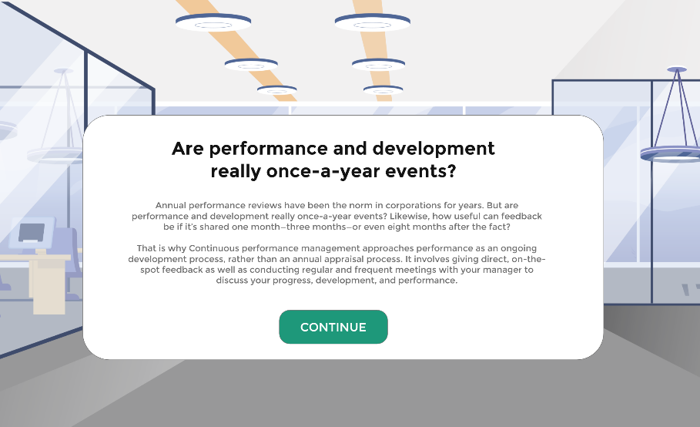
Screen Title: Ali’s scenario title slide
Text/Script | Navigation | On-Screen Graphics
{Banner Title/Heading}  Let's help Ali in optimizing the performance of both him and his team.  {Subheading}  You will now help Ali use continuous performance management to help him track his progress towards his goal, request feedback and have a better visibility on what his team is doing to offer the support needed.  {Button Caption}  Let’s go! | The learner will click on start button to start the scenario.
Screen Title: Question 1 – Remember to Update the CPM
Text/Script | Navigation | On-Screen Graphics
{Banner Title/Heading}  Ali is ready to start!  {Subheading}  Ali is really excited to start using the tool, but he is so busy with tasks and projects that he always forgets to update the CPM tool and check the activities of his team.  {Multiple Choice Question}  How can we make sure that Ali is consistent with using the tool and keeping track of his activities and the activities of his team?  {Multiple Choice Answers}  - Add a reminder on his calendar  - Create a sticky note and add it to his computer (sticky note is gone) – try again  - Add it on his notebook (notebook is lost) – try again  {Feedback for each choice}  - Correct response – this is the best approach. Ali now has set a reminder every end of the month to check the CPM board, update it when needed and check his team’s activities.  - He added a sticky note and stick it to his desk. However, one day the cleaner came and saw the sticky note on the floor, so he threw it.  - He added a note on his notebook. However, given his work, he kept on writing on the notebook and forgot where he initially wrote the note. | The learner will choose one of the choices. He/she will get feedback depending on the answer they choose.
Screen Title: Discover the tool
Text/Script | Navigation | On-Screen Graphics
He added a reminder for end of the week to take the time and familiarize himself with the process.  Let’s help him to learn more about the tool and how to use it on the system.  {Button Caption}  Discover the tool | When the learner click the button they will get a guided tour of the tool.
Screen Title: Ali’s Goals
Text/Script | Navigation | On-Screen Graphics
At the beginning of the year Ali added his goals on the system:

Business Goals
- Increase customer retention rate by 20% within 9 months
- Increase total store sales by 10% within 6 months
- Increase employee sales productivity by 10% within 6 months

Developmental Goal
Increase knowledge of competitors products and new market trends

Screen Title: Menu Screen
Text/Script | Navigation | On-Screen Graphics
Given Ali’s goals, let’s check how he can use the CPM tool with each of the features below.  - Add Activities & Achievements  - Gather Feedback  - Have a One-on-one Meeting with Manager  - Check Team’s Activities and Progress  - Request Feedback on behalf of the team | The user will click on the first one as the other four will be locked.
Screen Title: What is an activity?
Text/Script | Navigation | On-Screen Graphics
First, let’s make sure we all understand what an “Activity” is. Simply put, activities are the things you are working on. For example, if your goal is running a marathon, your activities might be things like running five miles a day, strength-training… They are personal to you and can be easily linked to one of your performance goals and/or development goals.

{Button Caption}
Continue
Screen Title: Add Activities and Achievements
Text/Script | Navigation | On-Screen Graphics
Choose the activities that Ali needs to put in his system.

Activities examples:
- Conduct webinar with regional sales team on the updated loyalty program
- Create new sales training deck about the most efficient sales techniques within the brand for the western region
- Arrange sessions with customers to collect feedback
- Create the customers purchasing patterns report with collaboration with the data analytics team
- Attend a virtual workshop on new market trends
- Organize the Employee of the month award ceremony
- Have lunch with the team on Tuesday
- Send an email to Bill to ask for updates on last month’s sales report

Feedback:
- Try again – make sure that the CPM tool is not a to do list but rather a high priority view on what you’re currently working on.

- Correct answer! You have selected the correct answer.

Screen Title: Activities Importance & Link to Goals
Text/Script | Navigation | On-Screen Graphics
Great! You have helped Ali in choosing which activities to add to the system. The activities on the system can also be categorized depending on the importance of each activity. Keep in mind that:  High - Really need to get this done as soon as possible  Medium - On my radar, but it could wait a day or two  Low- I’ll get to it when I have time  Ali can also link his activities to his performance goals and/or development goals. This is a great way to ensure that he is working on things that are relevant to the goals that he has established whether at the start of the calendar year or anytime throughout the year.  - Conduct webinar with regional sales team on the updated loyalty program  - Increase employee sales productivity by 10% within 6 months  - Create new sales training deck about the most efficient sales techniques within the brand for the western region  - Increase employee sales productivity by 10% within 6 months  - Arrange sessions with customers to collect feedback  - Increase customer retention rate by 20% within 9 months  - Create the customers purchasing patterns report with collaboration with the data analytics team  - Increase customer retention rate by 20% within 9 months  - Attend a virtual workshop on new market trends  Increase knowledge of competitors products and new market trends  - Organize the Employee of the month award ceremony  - Increase employee sales productivity by 10% within 6 months | Video - Then show the activities in the system as a picture.
Screen Title: Completed Activities and Achievements
Text/Script | Navigation | On-Screen Graphics
Great! Ali has his activities on the system now! With his activities in the system and the reminder on his calendar, he is now able to update his board each month or two to make sure that he is on track and his manager is up to date.  Now, let’s check how Ali can mark the completion of a task.  Once Ali completes a task, he just drags the task to the completed column. He can come back and add activities that he has already completed but forgot to add them in the first place.  Achievements  In many cases, the activities you are working on and complete will constitute a formal milestone or success for your career. So, when you mark any activity complete, the system will automatically prompt you to convert this activity into an achievement. You are not required to convert an activity into an achievement, but the option is there. | Drag & Drop  They can drag the activity and drop it in the completed section
Screen Title: Congratulations
Text/Script | Navigation | On-Screen Graphics
Congratulations! You have added Ali’s activities on the system!
You can collect your badge by clicking on Collect it button.
Screen Title: Menu Screen
Text/Script | Navigation | On-Screen Graphics
Given Ali’s goals, let’s check how he can use the CPM tool with each of the features below.  - Add Activities & Achievements  - Gather Feedback  - Have a One-on-one Meeting with Manager  - Check Team’s Activities and Progress  - Request Feedback on behalf of the team | The user will click on “Gather Feedback” to learn more.
Screen Title: Why Feedback is Important
Text/Script | Navigation | On-Screen Graphics
Do you want to be exceptional at your job? Deliver the best product or service? Add the most value to your team? Continue to grow and advance in your career? Then you need honest feedback from others on your behavior and performance. And to be meaningful, feedback needs to be specific, authentic, and immediate.

With feedback you gain insight into what you’re doing well and areas for improvement. And you can get it at the time it really matters. Receiving regular and direct feedback from managers, subordinates, and peers empowers us to grow as professionals and produce better results.

Feedback Drag and Drop Activity

This:
- Feedback is a learning opportunity
- It challenges me to improve and hone my skills
- It creates a stronger product, service or other results
- It’s exciting! It gives me a way to think about or do things.
- It’s a normal healthy part of any collaborative environement

Not that
- It’s not a personal attack on me, my character, or my abilities
- It does not mean that the other person dislikes me, is trying to be mean or thinks that I am bad at my job
- It’s not uncommon
- It’s not the end of the world or a sign of failure
- It’s not an excuse to give up, shut down, or stop trying.

{Button Caption}
Continue

Screen Title: Request Feedback
Text/Script | Navigation | On-Screen Graphics
Let’s now check how Ali can request and gather feedback for his completed tasks and achievements.

Created and presented the new sales training deck about the most efficient sales techniques within the brand for the western region. The training deck was beneficial for sales representatives and especially in the Western region to learn more about the techniques that are working best within this brand. However today he is so busy with many things and there are a lot of customers in the store.

What would you advise him to do?
- Wait for tomorrow as he doesn’t have time to deal with this today (He forgets and never had the chance to do it)
- During his lunch break, take 5 mins to request feedback on his performance

He got the below feedback

Manager Feedback:
Ali, your presentation was fantastic! You did an amazing job of highlighting the most effective sales techniques for the western region. The visuals you used were very effective and engaging. The only suggestion I have is to add more detail and context to each of the techniques so that your audience can better understand how they can apply them.

Peer Feedback:
Ali, your training deck was very informative and a great resource for the sales reps in the Western region. I especially liked how you included the graphics and examples to showcase the techniques. My suggestion would be to include some stats and figures to back up your points and give the presentation more weight.

{Button Caption}
Continue

Screen Title: Congratulations
Text/Script | Navigation | On-Screen Graphics
Congratulations! You have helped Ali in requesting feedback from his manager and peers!
You can collect your badge by clicking on Collect it button.
Screen Title: Menu Screen
Text/Script | Navigation | On-Screen Graphics
Given Ali’s goals, let’s check how he can use the CPM tool with each of the features below.  - Add Activities & Achievements  - Gather Feedback  - Have a One-on-one Meeting with Manager  - Check Team’s Activities and Progress  - Request Feedback on behalf of the team | After completing the first two sections, the learner will click on the last section.
Screen Title: Getting the Most Out of One-On-One Meetings with Your Manager
Text/Script | Navigation | On-Screen Graphics
One-on-ones offer an opportunity to get out of the daily grind and think about the big picture items—things like your progress, professional goals, feedback, and job interests or needs. They’re your biggest opportunity to talk about what’s most important to you—and have the undivided attention of your boss.

One-on-ones are unique because the topics covered in the meeting are largely up to you. While your manager will provide structure for the conversation, they’ll be looking to you to help shape and drive it. You determine the direction. Your manager will help you steer by asking questions and bringing up anything else they’d like to add.

That’s why the single greatest thing you can do to maximize your one-on-one time with your manager is to make an agenda or prepare what you’d like to talk about beforehand.

How to use the CPM tool to guide this.

Before your one-on-one meeting:
- Make sure your CPM tool is up to date to show it to your manager and highlight your progress and the challenges that you might be facing along the way
- Create a structure or a flow for the meeting
- Prepare any questions you might need to ask your manager

Screen Title: Congratulations
Text/Script | Navigation | On-Screen Graphics
Congratulations! You have helped Ali in creating a more structured meeting with his manager.
You can collect your badge by clicking on Collect it button.

Screen Title: Menu Screen
Text/Script | Navigation | On-Screen Graphics
Given Ali’s goals, let’s check how he can use the CPM tool with each of the features below.  - Add Activities & Achievements  - Gather Feedback  - Have a One-on-one Meeting with Manager  - Check Team’s Activities and Progress  - Request Feedback on behalf of the team | After completing the first two sections, the learner will click on the last section.
Screen Title: Check Team’s Activities and Progress
Text/Script | Navigation | On-Screen Graphics
The challenge is never knowing fully what Ali’s team is working on and using that information to ask insightful questions during the one-on-ones. It is also hard to find a simple approach to providing them some coaching advice each week as a way of helping them improve and stay motivated.  Well, with Continuous Performance Management, things just got a lot easier.  As a manager, Ali can view and add comments to his employee’s activities or topics. | Pictures
Screen Title:
Text/Script | Navigation | On-Screen Graphics
As a manager, how can Ali ensure that his employees get ongoing Feedback?  As a manager, Ali can request feedback on behalf of his employee. This is important, right? We all know feedback helps motivate employees and keep them engaged. It also provides valuable insight to employees on how they can improve. Managers like it because it helps create a more complete picture around performance and development progress.  Managers can request and provide employee feedback that’s general in nature and/or that’s tied to specific accomplishments. It’s easy for managers to access employee feedback and see how it aligns to specific activities and achievements.  Your role here is important. If employees are taking the time to create and add activities to the system but you are not checking them more engaging with them, this will also demotivate them.  The manager’s role here is crucial. By checking and engaging with employees who create and add activities to the system, you can motivate and encourage the team. This is essential for keeping your team motivated to add their activities so you can have more visibility around their goals and priorities.  Check this video to learn more about the best practices:  https://www.youtube.com/watch?v=INXyYn3E47I | Picture
Screen Title: How Ali’s situation changed
Text/Script | Navigation | On-Screen Graphics
How things changed with Ali
Throughout the year, and with continuously managing his performance through tracking his activities and progress towards his goals, asking and getting feedback, working on the feedback to enhance his performance. Ali feels more focused on his goals and valued in his company. He was getting the feedback and recognition he deserves.

His team is also now more engaged as they are aware that their manager has visibility over what they do and can support them whenever needed. The one-on-one meetings with the team are now structured and effective.

Ali is now surer of his ability to manage his team and tasks efficiently!

Screen Title: System Simulation Introduction
Text/Script | Navigation | On-Screen Graphics
Now, let’s make sure you are well aware of the system and its navigation.

Depending on the medium you use more, you can try to do the simulation through mobile or desktop.

In the upcoming simulation, we will be adding two activities:
- Conduct webinar with regional sales team on the updated loyalty program
- Create new sales training deck about the most efficient sales techniques within the brand for the western region

Screen Title: System Simulation – Add an Activity
Text/Script | Navigation | On-Screen Graphics
• To begin, simply open up iGrow from the Al-Futtaim intranet.
• Click on Home, then click Continuous Performance
Pretty easy right? That’s only the beginning. Let’s now help you understand the different features we offer in the solution.

“ Below steps should be an actual simulation where users will click on each step”

Desktop
- Go to Sucessfactors and click on IGrow
- From the dropdown menu, click on continuous performance
- Click “Create Activity”
- Enter an activity name, status
- High: Really need to get this done as soon as possible
- Medium: On my radar, but it could wait a day or two
- Low: I’ll get to it when I have time
- Paused: Something got in the way and it’s on hold
- Cancelled: No longer happening but want to preserve
- Complete: I did it! Time to celebrate.
- You may choose to link to a performance goal, development goal or both
- Click Save

Click here to know more about how to access SuccessFactors App through mobile.

- Download the Successfator app first
- Go to iGrow page on the intranet
- Click on your profile photo on the home page
- Click on Settings
- Click on Mobile
- Click on Activate via Camera
- Open your Successfator app to scan the QR code

Create an Activity
- Open the SuccessFactors App on your mobile
- Click “Create Activity”
- Enter an activity name, status
- You may choose to link to a performance goal, development goal or both (optional)
- Click Save
Screen Title: System Simulation – Convert an Activity to Achievement
Text/Script | Navigation | On-Screen Graphics
“ Below steps should be an actual simulation where users will click on each step and be able to add text“

Through mobile & Desktop
- Click on the activity
- Click Edit
- Choose status “complete” from the drop down.
- Tick to mark as an achievement
- You may choose to link to a performance goal, development goal or both
- Click Save
Screen Title: System Simulation – Note
Text/Script | Navigation | On-Screen Graphics
We took you through steps on how to add your achievements.
Earlier, you saw what an activity is — Activities are the things you are working on. Achievements in many cases represent the completion of an activity.
But Achievements may also have no relationship to activities, which is perfectly fine. For example, you might have volunteered to do something as part of an initiative around corporate responsibility. Or you might have stepped in at the last minute to close a deal. It might not have been noted as an activity, but it certainly can count as an achievement.

Screen Title: System Simulation – Request Feedback
Text/Script | Navigation | On-Screen Graphics
Below steps should be an actual simulation where users will click on each step”

Desktop
- Click on an activity
- Click on “Request Feedback”
- Enter the name of the person(s) you want to ask feedback from by
– Searching for that name
– Clicking on the name that is auto-populated
- Review the suggested text and customize as desired
- Click “Send”
- Wait for system confirmation and click “Ok”

Mobile
- Open the SuccessFactors App on your mobile
- Click on “More”
- Click on “My Activities”
- Click on an Activity that you want feedback
- Click on 3 dots … at the top right
- Click on Request Feedback
- Enter the name of the person(s) you want to ask feedback from by
– Searching for that name
– Clicking on the name that is auto-populated
- Review the suggested text and customize as desired
- Click “Send”
Screen Title: System Simulation – Feedback Note
Text/Script | Navigation | On-Screen Graphics
Note that you can also Request or Give Ad hoc Feedback. It is not only limited to a specific activity.
Screen Title: System Simulation – Feedback Note
Text/Script | Navigation | On-Screen Graphics
Desktop
Enter the name of the person(s) you want to ask feedback from by
– Searching for that name
– Clicking on the name that is auto-populated
- Review the suggested text and customize as desired
- Click “Send”
- Wait for system confirmation and click “Ok”

Mobile
“ Below steps should be an actual simulation where users will click on each step”
- Open the SuccessFactors App on your mobile
- Click on Request Feedback
- Enter the name of the person(s) you want to ask/give feedback from by
– Searching for that name
– Clicking on the name that is auto-populated

Screen Title: System Simulation – Checking Employees Activities
Text/Script | Navigation | On-Screen Graphics
Let’s see how you can view your employees' activities.

Desktop
- On the iGrow Home Page
- Click on My Team
- Click on “Go To” and then Click on Activities in the drop down menu
- You can view activities added by your employees and add new activities for them if needed
You can also access the employees activities via the Continuous Performance Tab on the Home Page.

Mobile
- Open the SuccessFactors App on your mobile
- Click on “Team” icon at the bottom
- Click on the employee you want to view the activities for
- Click on Activities
- To add an activity click on the + sign

Screen Title: System Simulation – Requesting Feedback on behalf of your employees
Text/Script | Navigation | On-Screen Graphics
As a manager, you can request feedback on behalf of your employee. This is important, right? We all know feedback helps motivate employees and keep them engaged. It also provides valuable insight to employees on how they can improve. Managers like it because it helps create a more complete picture around performance and development progress.

Managers can request and provide employee feedback that’s general in nature and/or that’s tied to specific accomplishments. It’s easy for managers to access employee feedback and see how it aligns to specific activities and achievements.

Screen Title: System Simulation – Requesting Feedback
Text/Script | Navigation | On-Screen Graphics
Desktop
- Select an employee from the left panel in the Activities view
- Click on the Activity
- Click “Request Feedback”
- Enter the name of the person(s) you want to solicit feedback from by:
- Searching for that name
- Clicking on the name that is auto-populated
- Review the suggested text and customize as desired
- Click “Send”

Mobile
- Open the SuccessFactors App on your mobile
- Click on “Team” icon at the bottom
- Click on the employee you want to view the activities for
- Click on “Activities”
- Click on the activity you want to receive feedback on
- Click on the 3 dots …
- Click on Request Feedback

